**Assignment description:**

The assignment will encompass lessons (2-8) taught on the Writing and Editing Skills course, these are: *Researching the Product, Consumer Needs and Behavior, Creative Briefs, Rhetorical Appeals, and Figurative Language*.

Students will work individually and are expected to write a 1000 word essay analyzing the copywriting of 2 real-world campaign posters in terms of its use of rhetorical appeals, Figurative language, target market, Needs, features and benefits, etc.

**Process:**

Students are expected to research the campaign’s brand and history, analyze the copywriting and produce an original 1000 (+/-10%) word essay.

**Deliverables** :

• Produce a 1000 word essay (+/-10%) of original work, analysis and research. • Provide an overview of the brand, product and campaign.

• Analyze and discuss the posters’ copywriting in terms of its target market, key insight, rhetorical appeals and consumer needs.

• Analyze the copywriting in terms of its figurative language.

• Must illustrate arguments/points using examples of similar copy, previous brand advertisements, etc.

• Harvard Referencing must be used. **Any use of plagiarism will result in Mark Deduction**.

• Evaluate the effectiveness of the copywriting and its effect on consumers.

**Choose any two of the following posters to discuss and analyze**

**LEGO**

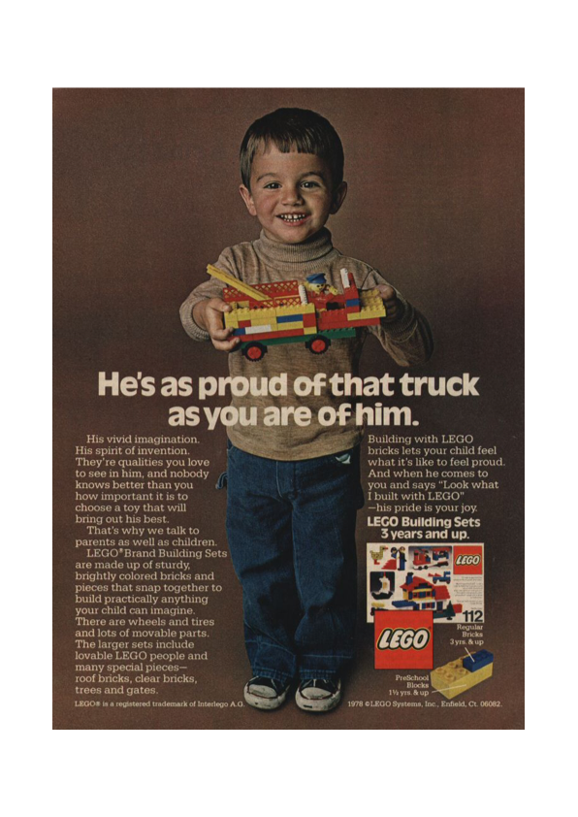

NIKE

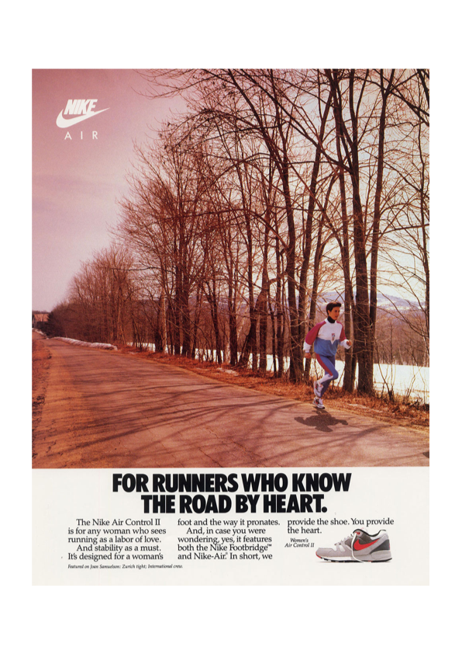

PORSCHE

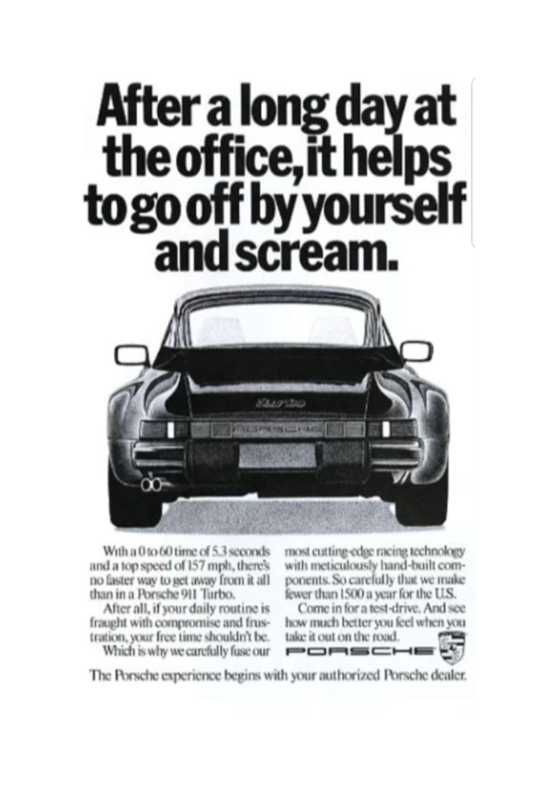

**Innocent Drinks**

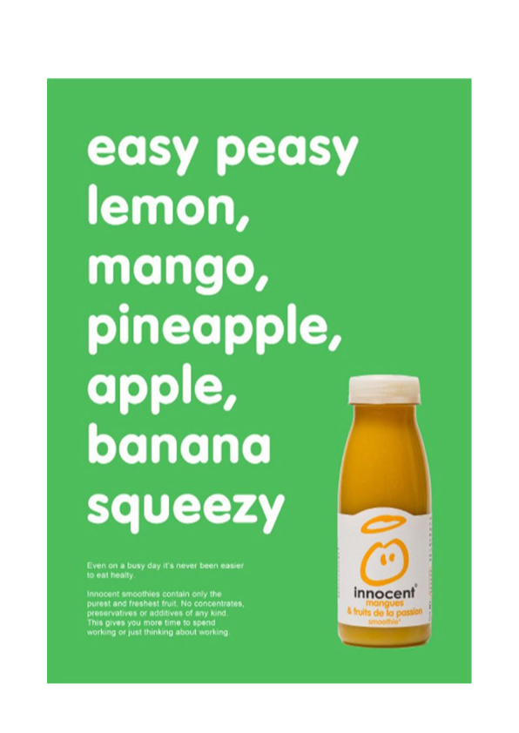

**St. Vincent’s Healthcare**



**McDonald’s**

page7image441399872

